Gibbs (1988) model of reflection:
Especially good for emotionally charged cases
Gibbs is another common model of reflection that is used within the health professions. Gibbs is clear and precise allowing for description, analysis and evaluation of the experience helping the reflective practitioner to make sense of experiences and examine their practice. To reflect is not enough, you then have to put into practice the learning and new understanding you have gained therefore allowing the reflective process to inform your practice. Taking action is the key; Gibbs prompts the practitioner to formulate an action plan. This enables the reflective practitioner to look at their practice and see what they would change in the future, how they would develop/improve their practice.

Gibbs (1988)
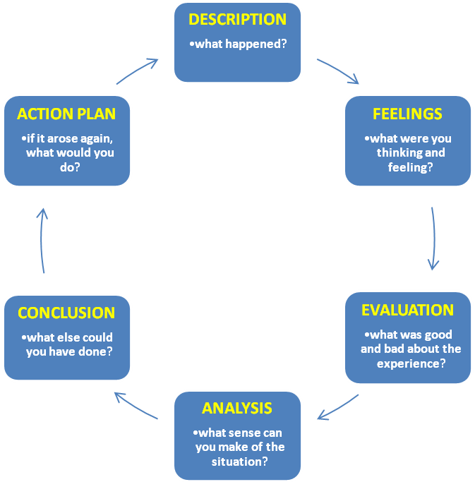

Gibbs, G. (1988). Learning by Doing: a guide to teaching and learning methods. London: Further Education Unit,

Gibbs (1988) model of reflection
Description
This is context of the event .e.g.
Who was there?
Why were you there?
What was happening?

Feelings thoughts
This is self awareness .e.g.
How did you feel?
How did the others around you feel?
How did you feel about the outcome of the event?

Evaluation
Consider your judgments.eg.
Consider what went well, what not so well.
What was good and not so good about your experience

Analysis
Break down the event and explore each part separately, here you may need to ask yourself more detailed questions

Conclusion
This is the synthesis. During this stage you should be exploring what you could have done differently.

Action plan
Consider what you would do differently if you encountered this situation again.
Would you act differently or do the same?

